**Logo Design**

Whether it is your business card, letterhead or a brochure, the first thing that gets noticed is your logo design. Your Logo is the foundation of your brand – getting it right is fundamentally important. Let the Quick Designs creative team help you lay a stronger foundation for the brand that can dominate the market for you.



Your logo design is the first step towards building a brand. A logo must be strong, eye catching and unique having the ability to set your business apart from the crowd.

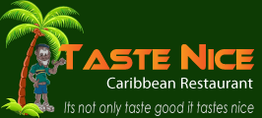

We at Quick Web Designs strive to exceed customer expectations by working with our clients as if it were our own business. Our process ensures that we understand your business and analyze the competition before coming up with a logo design concept.

**What is included in the Logo Design Package?**

* 5 concepts
* Unlimited revisions
* Print & web ready formats
* 100% satisfaction